**Laptop Request Catalog Item using ServiceNow**



***Team ID:*** NM2025TMID20111

**Team Members: Team Leader: Karthick B**

**Team Member 1: Yogesh Kumar C**

**Team Member 2: Jhon Simon**

**Team Member 3: Vasanth B**

**Category:** ServiceNow System Administrator **Problem**

**Statement:**

**Employees in the organization need a quick and efficient way to request laptops for work. The current process is manual, prone to delays, and lacks dynamic form behavior to guide users or ensure accurate data collection. This often results in incomplete requests, miscommunication, and inefficiencies.**

**Objective:**



**To design and implement a Service Catalog item in ServiceNow that enables employees to easily request laptops with:**

**Dynamic fields based on user selections. Clear instructions for accurate data entry. A reset option for the form when needed.**

**End-to-end** **tracking** **of** **all** **changes** **for governance and deployment.**

**Skills Required:**

**ServiceNow Catalog Item Development**

**ServiceNow Client Scripts & UI Policies**

**Flow Designer / Workflow Configuration**

**Data Governance & Change Management**

**Project Description:**



**This project aims to build a Laptop Request Service Catalog Item on the ServiceNow platform. The system will allow users to:**

**Submit structured laptop requests through a guided form.**

**Experience** **dynamic** **field** **behavior (show/hide/require fields based on selections). Reset the request form when necessary.**

**Trigger automated approvals and fulfillment workflows.**

**Ensure all changes and deployments are tracked for governance.**

**Generate reports on requests, approvals, and fulfillment** **metrics** **for** **better** **IT** **asset management.**

**TASK INITIATION**

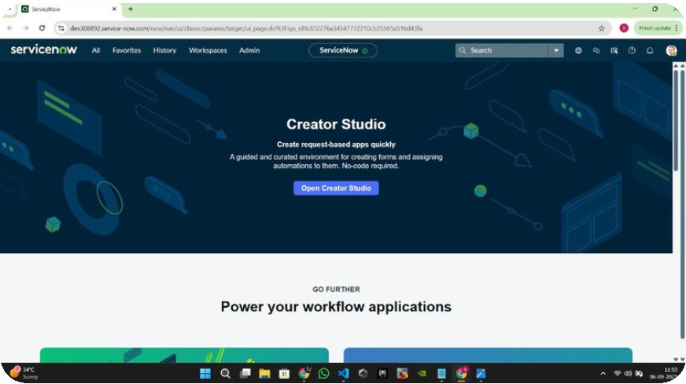

**Milestone 1 :** Setting up ServiceNow Instance **Activi**[**ty 1:** C](https://developer.servicenow.com/)reate and Access Instance

1. **Open** [**ServiceNow Developer Site.**](https://developer.servicenow.com/)

2. **Sign up for a developer account and log in.** 3. **Navigate to Personal Developer Instance.**

4. **Click Request Instance and fill the required details.** 5. **Submit the request.**

6. **Once approved, check your email for instance details.** 7. **Log in using the provided credentials.**

8. **Verify that you can successfully access and navigate the instance.**

**Milestone 2 :** Create Local Update Set

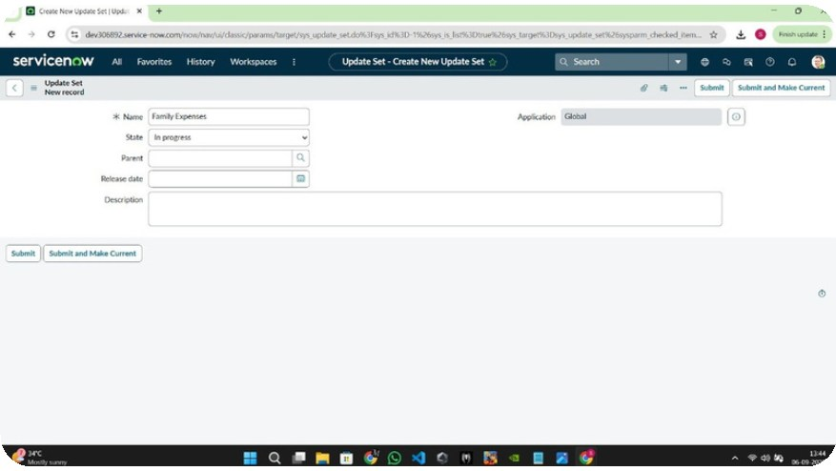

**Activity 1:** Create Update Set 1.**Open service now.**

2.**Click on All >> search for update sets**

3.**Select local update sets under system update sets** 4.**Click on new**

5.**Fill the following details to create a update set as: “Laptop Request”** 6.**Click on submit and make current**

7.**By clicking on the button it activates the update set .**

**Milestone 3:** Creation of Service Catalog Item

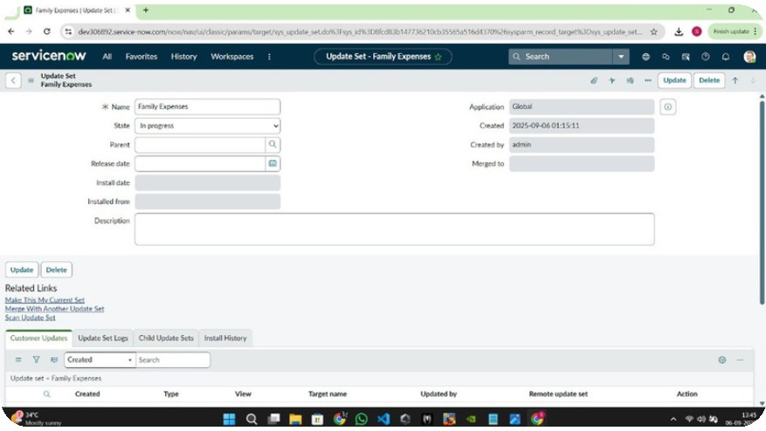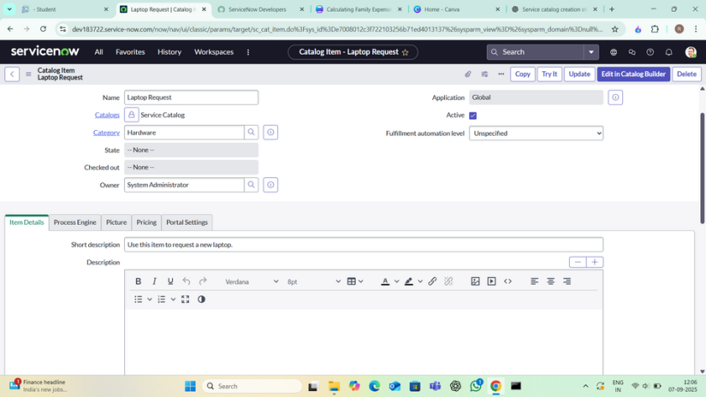

**Activity 1:** Create Service Catalog Item 1.**Open service now.**

2.**Click on All >> service catalog**

3.**Select maintain items under catalog definitions** 4.**Click on New.**

5.**Fill the following details to create a new catalog item** 6.**Name: Laptop Request**

7.**Catalog: service Catalog** 8.**Category: Hardware**

9.**Short Description: Use this item to request a new laptop** 10.**Click on ‘SAVE’**

**Milestone 3: Add variables**

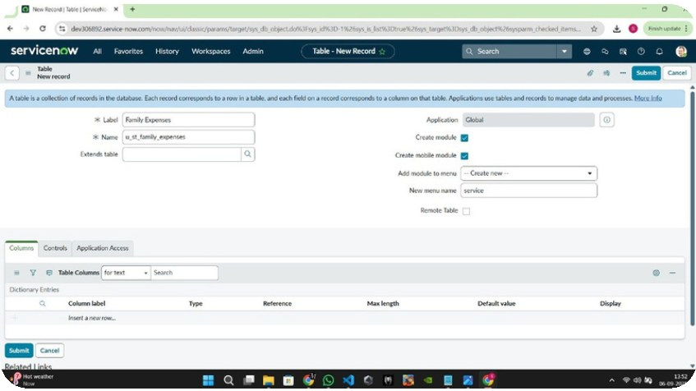

**Activity 2: Add variables Step1:**

**After saving the catalog item form scroll down and click on variable(related list)**

**Click on new and enter the details as below 1. Variable 1:Laptop Model**

**Type: Single line text Name: laptop_model Order:100**

**Click on submit**

**Again click on new and add Remaining variables in the above process** 2. Variable 2:Justification

Type: Multi line text Name: justification Order:200

3. Variable 3:Additional Accessories Type: Checkbox

Name: additional_accessories Order:300

4. Variable 4: Accessories Details Type: Multi line text Name:accessories_details Order:400

**Step2:**

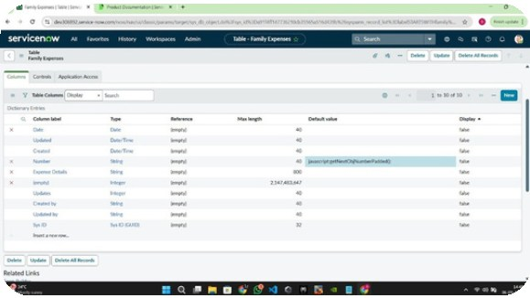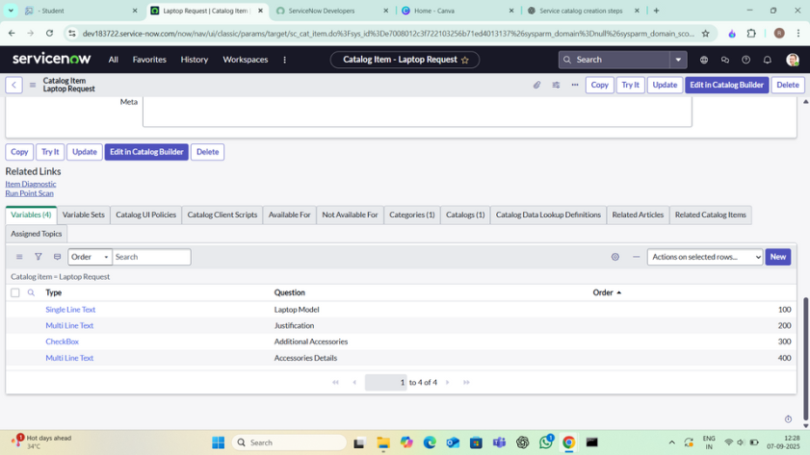

After adding above variable which are added to newlycreated catalog item

Then save the catalog item form

**Milestone 4 : creation UI Policy**

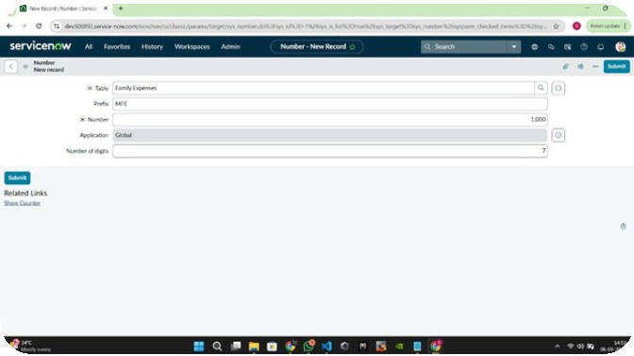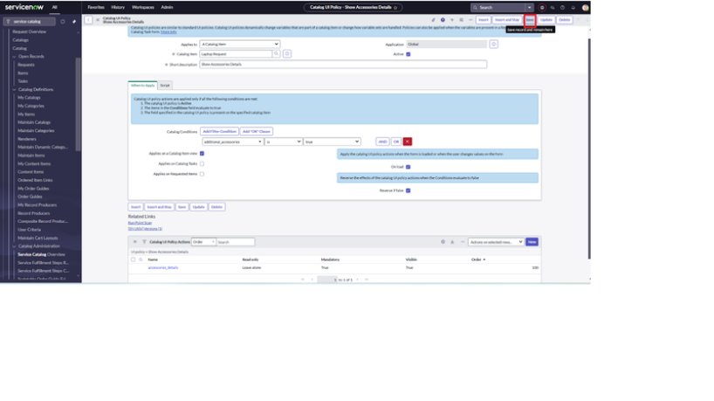

**Activity 1: Create Catalog Ui policies**

1.**Click on all>> search for service catalog** 2.**Select maintain item under catalog definition**

3.**Search for ‘laptop request’ which is created before**

4.**Select ‘laptop request’ and scroll down click on “Catalog Ui policies”** 5.**In the catalog ui policies related list tab click on new**

6.**Give short description as: show accessories details**

7.**Set the Catalog Condition in the related list tab ‘when to apply’ [field: additional_ accessories, operator: is, value: true]**

**8.Click on save.(do not click on submit) 9.Scroll down and select ‘catalog ui action’ 10.Then click on new button**

**11.Select variable name as: accessories_details Order:100**

**Mandatory: True Visible : True**

**12.Click on save and again click save button of the catalog ui policy form.**

**Milestone 5: UI ACTIONS**

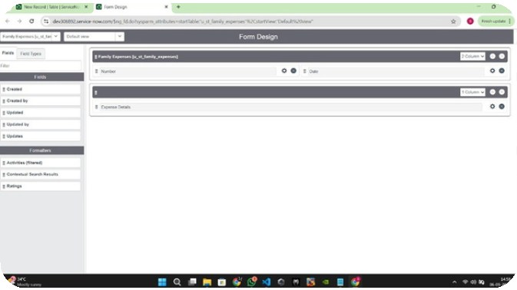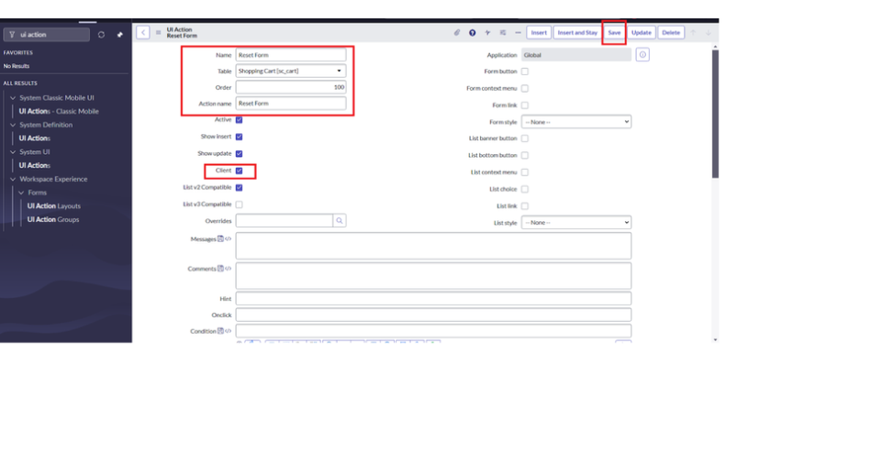

**Activity 5: Create ui action**

1.Open service now.

2.Click on All >> search for ui action 3.Select ui actions under system definition 4.Click on new

5.Fill the following details to create ui action Table: shopping cart(sc_cart) Order:100

Action name: Reset form Client : checked

Script:

function resetForm() {

g_form.clearForm(); // Clears all fields in the form alert("The form has been reset.");

}

Click on save

**Milestone 8: Export Update set**

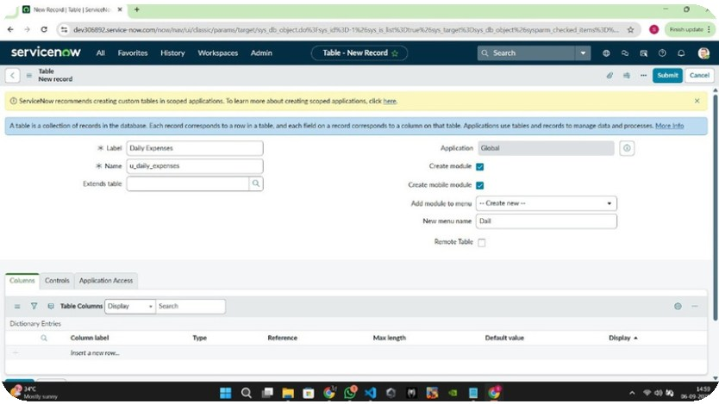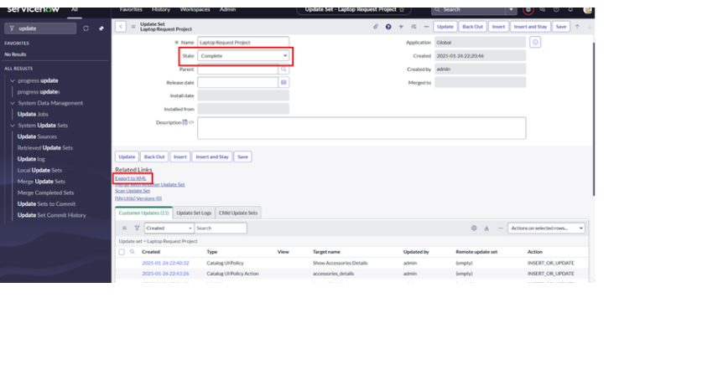

**Activity 1: Exporting changes to another instance**

1.**Click on All >> search for update sets** 2.**Select local update set**

3.**Select created update set i.e. ‘Laptop Request Project’** 4.**Set the state to ‘Complete’**

5.**In the related list Update tab, updates are visible which we perform under this update set.**

6.**Click on export to XML ,it download one file**

**Milestone 6 : Login to another Instance**

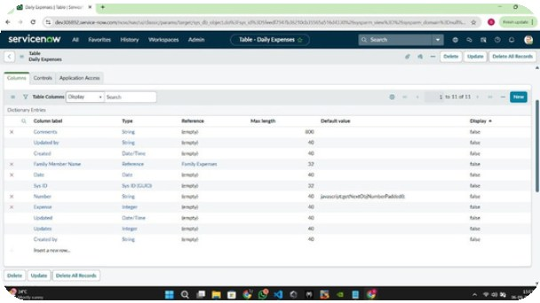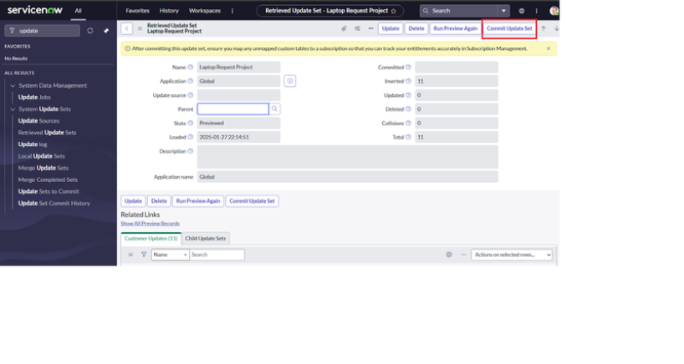

**Activity 1: Retrieving the update set**

1.**Open another instance in incognito window** 2.**Login with credentials**

3.**Click on all>> search for update sets**

4.**Select “Retrieved update set” under system update set** 5.**It open retrieved update set list and scroll down** 6.**Click on Import update set from XML**

7.Upload the downloaded file in XML file 8.Click on Upload and it gets uploaded.

9.Open retrieved update set ‘laptop request project’ 10.Click on preview update set

11.And click on commit update set 12.And also see the related tab updates

13.After commiting update set in this instance we get all updates which are done in the previous instance

**Milestone 7 : Testing**

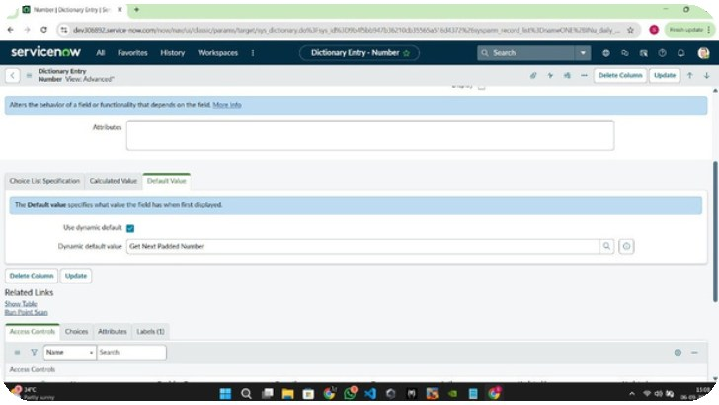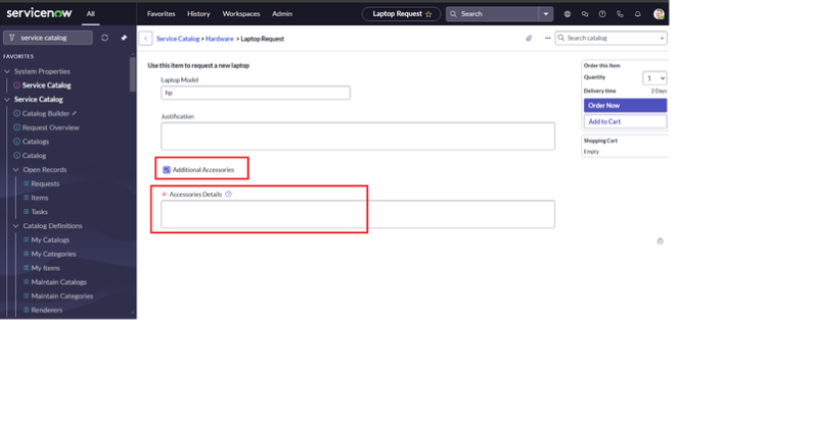

**Acivity 3: Test Catalog Item**

1.**Search for service catalog in application navigator in target instance**

2.**Select catalog under service catalog**

3.**Select hardware category and search for ‘laptop request’ item** 4.**Select laptop request item and open it**

5.**It shows three variables only**

6.**As per our scenario, when we click on additional accessories checkbox then accessories details fields is visible and that should be mandatory**

7.**Now see the results,it fulfills our requirements.**

**Conclusion:**



The Laptop Request Catalog Item project successfully streamlines the process of requesting laptops within the organization by leveraging ServiceNow's Service Catalog capabilities. Through the implementation of a dynamic catalog item, the project ensures that users have an intuitive and user-friendly interface, reducing errors and improving efficiency.This project demonstrates how ServiceNow can be used to replace manual, error-prone processes with automated, efficient, and user-centric solutions. It not onlyimproves service delivery but also enhances employee satisfaction by providing a modern and streamlined request experience.